**Spring REST using Spring Boot 3**

***Hands on 1***

***Create a Spring Web Project using Maven***

**Project Structure**

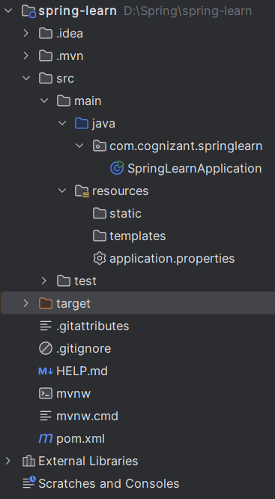

***Code Snippets***

1. *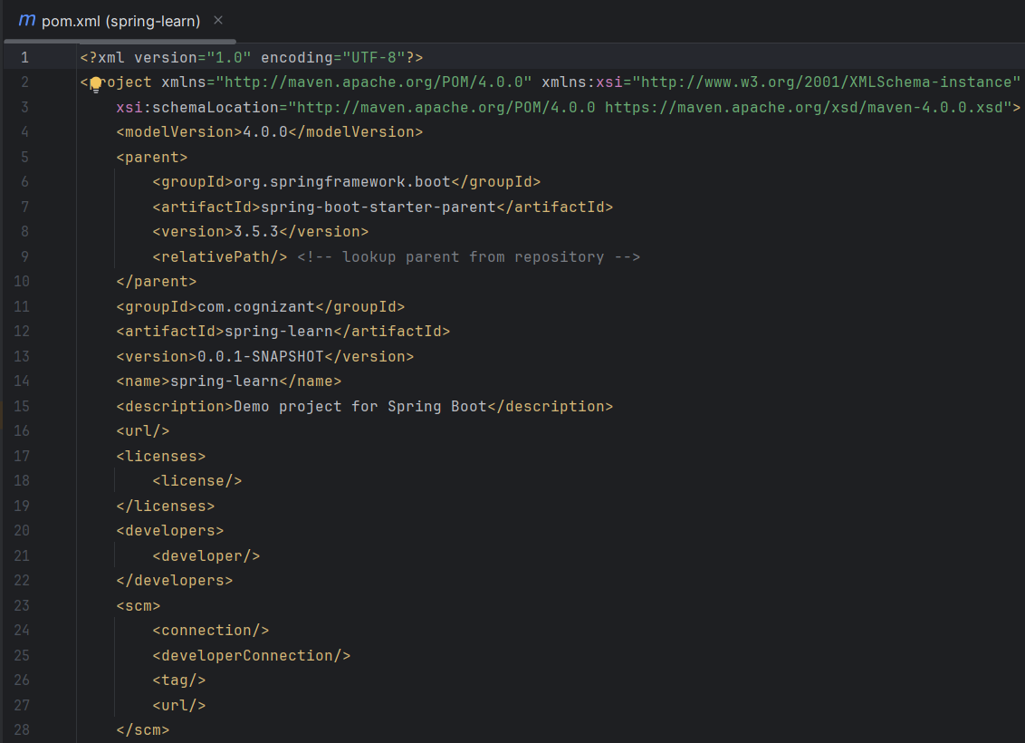Pom*.*xml*

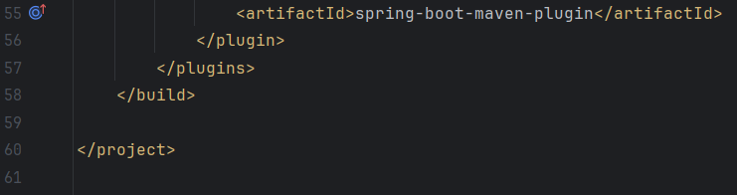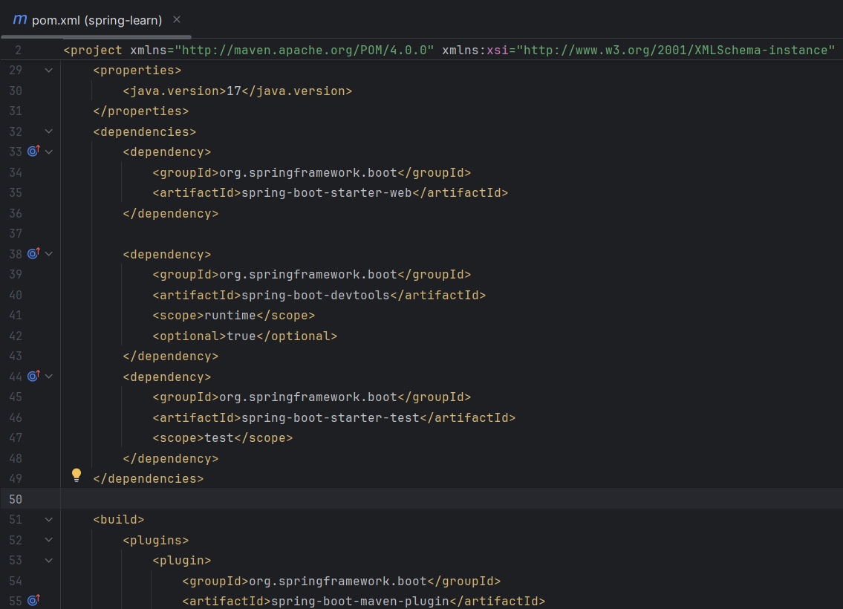

1. *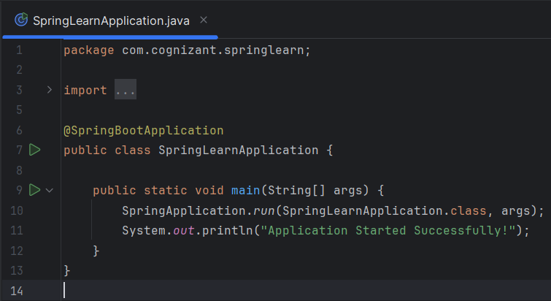SpringLearnApplication*.*java*

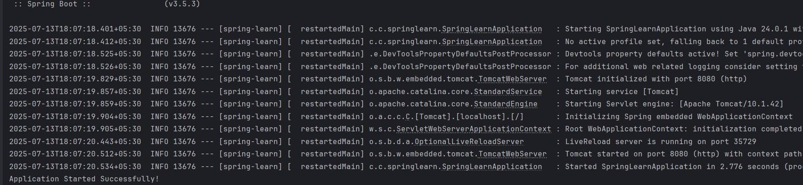***Output Screenshot***